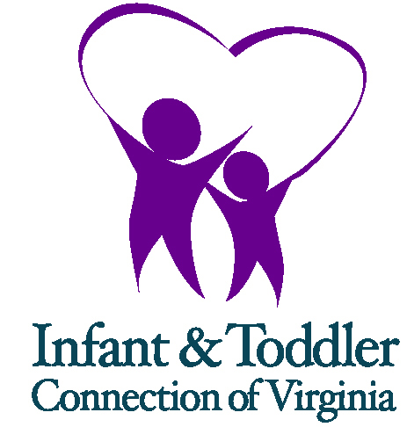 | Notification to the  Department of Medical Assistance Services:  Family Declining to Bill Private Insurance

The parent(s) of ________________________________ (child’s name) has declined access to their private health/medical insurance for covered early intervention services.

_______________________________________
Name of Local Part C System Representative

_______________________________________
Signature of Local Part C System Representative

_______________________________________
Date

